*Table 1: Overview of baseline characteristics, ECG-measurements and ECG abnormalities for both the apparently healthy population and the healthy follow-up population. Continuous variables are present as mean (SD). *Sokolow-Lyon or Cornell voltage criteria for LVH.*

|  |  |  |
| --- | --- | --- |
|  | Baseline cohort | Follow-up cohort |
| Total (n) | 11276 | 4468 |
| Age in years | 39 (12) | 40 (12) |
| Age range in years | 18-71 | 18-71 |
| Female sex (%) | 6873 (61) | 2720 (61) |
| Body mass index | 26 (5) | 25 (4) |
| Ethnicity |  |  |
| Dutch (%) (Western-European) | 2722 (24) | 1554 (35) |
| South Asian-Surinamese (%) (South Asian-South American) | 1395 (12) | 627 (14) |
| African-Surinamese (%) (African-South American) | 1713 (15) | 700 (15) |
| Ghanaian (%) (Sub-Sahara Western-African) | 895 (8) | 224 (5) |
| Turkish (%) (Middle-Eastern) | 2074 (18) | 530 (12) |
| Moroccan (%) (Northern-African) | 2477 (22) | 833 (19) |
| ECG-measurements |  |  |
| Heart rate (bpm) | 62 (9) | 61 (9) |
| P-wave duration (ms) | 109 (11) | 109 (11) |
| PR-interval (ms) | 157 (22) | 158 (23) |
| QRS-duration (ms) | 92 (9) | 92 (9) |
| QT-interval (ms) | 407 (28) | 410 (28) |
| QTc Bazett (ms) | 412 (22) | 412 (21) |
| Frontal P-wave axis (degrees) | 46 (22) | 47 (22) |
| Frontal QRS-complex axis (degrees) | 44 (30) | 45 (30) |
| Frontal T-wave axis (degrees) | 39 (18) | 40 (18) |
| Ventricular gradient (mV·ms) | 92 (33) | 93 (3) |
| Spatial QRS-T angle (degrees) | 42 (22) | 42 (21) |
| Normal spatial QRS-T angle (0-105 degrees) (%) | 11127 (99) | 4416 (99) |
| Borderline spatial QRS-T angle (105-135 degrees) (%) | 129 (1) | 47 (1) |
| Abnormal spatial QRS-T angle (135-180 degrees) (%) | 19 (0.2) | 5 (0.1) |
| Sum absolute QRS-T integrals (mV·ms) | 156 (55) | 158 (56) |
| ECG abnormalities |  |  |
| Abnormal Q waves/High R-waves V1/V2 (%) | 27 (0.2) | 11 (0.2) |
| High QRS voltage (ESC hypertension guideline (15)) (%) | 2470 (22) | 897 (20) |
| High QRS voltage (composite criteria*) (%) | 720 (6) | 245 (6) |
| Low QRS voltage | 94 (0.8) | 49 (1) |
| Abnormal T-wave/repolarization (%) | 58 (0.5) | 17 (0.4) |
| Early repolarization pattern (ERP) (%) | 2619 (23) | 996 (22) |
| Lateral (I,aVL), inferior (II,aVF,III) and anterolateral (V4,V5,V6) ERP (%) | 8 (0.1) | 1 (0.0) |
| Lateral and anterolateral ERP (%) | 66 (0.6) | 26 (0.6) |
| Inferior and lateral ERP (%) | 3 (0.0) | 1 (0.0) |
| Inferior and anterolateral ERP (%) | 526 (5) | 215 (5) |
| Inferior ERP (%) | 1208 (11) | 461 (10) |
| Lateral ERP (%) | 326 (3) | 114 (3) |
| Anterolateral ERP (%) | 482 (4) | 178 (4) |

*Table 2. Overview of baseline characteristics, ECG-measurements and ECG abnormalities for the apparently healthy population, stratified by ethnicity. Continuous variables are present as mean (SD unless stated otherwise). *Calculated using Wald test from mixed-effect models*

|  |  |  |  |  |  |  |  |
| --- | --- | --- | --- | --- | --- | --- | --- |
|  | Dutch | South Asian-Surinamese | African-Surinamese | Ghanaian | Turkish | Moroccan | p-value* |
| Total | 2722 | 1395 | 1713 | 895 | 2074 | 2477 |  |
| Age in years | 42 (13) | 38.0 (12) | 41.4 (12.4) | 38.2 (11.4) | 36.1 (11.1) | 36.1 (11.4) | <0.001 |
| Female sex (%) | 1613 (59) | 800 (57) | 1069 (62.4) | 598 (66.8) | 1180 (56.9) | 1613 (65.1) | <0.001 |
| Body mass index | 24 (3) | 24.9 (5) | 26.0 (4.6) | 26.8 (4.6) | 27.1 (5.0) | 26.4 (4.8) | <0.001 |
| ECG-measurements |  |  |  |  |  |  |  |
| Heart rate (bpm) | 59 (9) | 65 (10) | 63 (9) | 63 (9) | 64 (9) | 63 (9) | <0.001 |
| P-wave duration (ms) | 110 (11) | 106 (11) | 111 (11) | 112 (10) | 108 (10) | 109 (11) | <0.001 |
| PR-interval (ms) | 157 (23) | 151 (21) | 161 (23) | 165 (23) | 153 (21) | 157 (22) | <0.001 |
| QRS-duration (ms) | 95 (9) | 90 (9) | 90 (9) | 88 (9) | 93 (9) | 92 (9) | <0.001 |
| QT-interval (ms) | 420 (28) | 405 (27) | 402 (26) | 390 (25) | 406 (26) | 404 (25) | <0.001 |
| QTc Bazett (ms) | 414 (21) | 413 (22) | 408 (21) | 398 (21) | 415 (21) | 412 (21) | <0.001 |
| P-wave frontal axis (degrees) | 47 (23) | 46 (20) | 48 (23) | 478 (23) | 45 (22) | 46 (21) | <0.001 |
| QRS-complex frontal axis (degrees) | 48 (32) | 46 (28) | 41 (30) | 45 (26) | 44 (32) | 42 (29) | <0.001 |
| T-wave frontal axis (degrees) | 44 (17) | 36 (18) | 36 (19) | 35 (18) | 39 (18) | 40 (17) | <0.001 |
| Abnormal Q waves/High R waves V1/V2 (%) | 8 (0.3) | 5 (0.4) | 1 (0.1) | 1 (0.1) | 5 (0.2) | 7 (0.3) | 0.504 |
| High QRS-voltage (ESC hypertension guideline) (%) | 638 (23) | 182 (13) | 529 (31) | 351 (39) | 289 (14) | 481 (19) | <0.001 |
| High QRS-voltage (composite criteria) (%) | 150 (6) | 47 (3) | 172 (10) | 154 (17) | 61 (3) | 136 (6) | <0.001 |
| Low QRS-voltage (%) | 24 (1) | 22 (2) | 6 (0.4) | 1 (0.1) | 27 (1) | 14 (0.6) | <0.001 |
| Abnormal T-wave/repolarization (%) | 8 (0.3) | 5 (0.4) | 19 (1) | 9 (1) | 9 (0.4) | 8 (0.3) | 0.001 |
| Early repolarization pattern (ERP) (%) | 520 (19) | 325 (23) | 508 (29.7) | 359 (40.1) | 410 (19.8) | 497 (20.1) | <0.001 |
| Lateral (I,aVL), inferior (II,aVF,III) and anterolateral (V4,V5,V6) ERP (%) | 0 (0.0) | 0 (0.0) | 0 (0.0) | 4 (0.4) | 1 (0.0) | 3 (0.1) | <0.001 |
| Lateral and anterolateral ERP (%) | 10 (0.4) | 5 (0.4) | 22 (1) | 13 (1) | 6 (0.3) | 10 (0.4) | <0.001 |
| Inferior and lateral ERP (%) | 1 (0.0) | 0 (0.0) | 1 (0.1) | 0 (0.0) | 0 (0.0) | 1 (0.0) | 0.836 |
| Inferior and anterolateral ERP (%) | 97 (4) | 69 (5) | 124 (7) | 92 (10) | 60 (3) | 84 (3) | <0.001 |
| Inferior ERP (%) | 288 (11) | 163 (12) | 167 (10) | 125 (14) | 241 (12) | 224 (9) | 0.001 |
| Lateral ERP (%) | 46 (2) | 32 (2) | 81 (5) | 37 (4) | 51 (3) | 79 (3) | <0.001 |
| Anterolateral ERP (%) | 78 (3) | 56 (4) | 113 (7) | 88 (10) | 51 (3) | 96 (4) | <0.001 |
| Ventricular gradient (mV·ms) | 98 (35) | 88 (31) | 92 (34) | 96 (31) | 86 (30) | 93 (31) | <0.001 |
| Spatial QRS-T angle (degrees) | 46 (22) | 41 (21) | 40 (22) | 38 (21) | 44 (22) | 38 (20) | <0.001 |
| Normal spatial QRS-T angle (0-105 degrees) (%) | 2680 (99) | 1378 (99) | 1687 (99) | 887 (99) | 2044 (99) | 2451 (99) | 0.473 |
| Borderline spatial QRS-T angle (105-135 degrees) (%) | 36 (1) | 16 (1) | 22 (1) | 6 (0.7) | 25 (1) | 24 (1) | 0.611 |
| Abnormal spatial QRS-T angle (135-180 degrees) (%) | 6 (0.2) | 1 (0.1) | 4 (0.2) | 2 (0.2) | 5 (0.2) | 1 (0.0) | 0.432 |
| Sum absolute QRS-T integral (mV·ms) | 165 (59) | 149 (53) | 155 (58) | 162 (53) | 145 (51) | 157 (53) | <0.001 |

*Table 3. The prevalence of the high QRS-voltage criteria stratified by age group, sex and ethnicity, for the total cohort, the Dutch, the African-Surinamese and Ghanian combined and the Turkish and Moroccan combined. *Mancia et al, EHJ 2013 \*\** *Sokolow-Lyon or Cornell voltage criteria for LVH.*** Calculated using Wald test from mixed-effect models*

|  |  |  |  |  |  |  |  |  |
| --- | --- | --- | --- | --- | --- | --- | --- | --- |
|  | Total | | Dutch | | African-Surinamese/ Ghanaian | | Turkish/Moroccan | |
|  | Male | Female | Male | Female | Male | Female | Male | Female |
| Age <40 years | | | | | | | | |
| Total | 2267 | 3696 | 522 | 735 | 276 | 474 | 1008 | 1767 |
| ESC hypertension guideline % (95% CI) | 49  (47-52) | 12  (11-13) | 54  (50-59) | 16  (14-19) | 67  (61-73) | 19  (16-23) | 43  (40-47) | 7  (6-8) |
| Composite criteria* % (95% CI) | 13  (11-14) | 3  (3-4) | 10  (8-13) | 5  (3-6) | 24  (19-29) | 5  (3-7) | 10  (8-12) | 2  (1-2) |
| Age ≥40 years | | | | | | | | |
| Total | 2136 | 3177 | 587 | 878 | 368 | 595 | 750 | 1026 |
| ESC hypertension guideline % (95% CI) | 29  (27-31) | 9  (8-10) | 25  (21-28) | 10  (8-12) | 46  (41-52) | 14  (11-16) | 20  (17-22) | 6  (4-7) |
| Composite criteria* % (95% CI) | 8  (7-9) | 4  (4-5) | 5  (3-7) | 3  (2-4) | 13  (10-17) | 6  (4-8) | 5  (3-6) | 3  (2-4) |

*Figure 1: Patient inclusion process of both the apparently healthy and healthy after follow-up populations.*Categories may overlap*

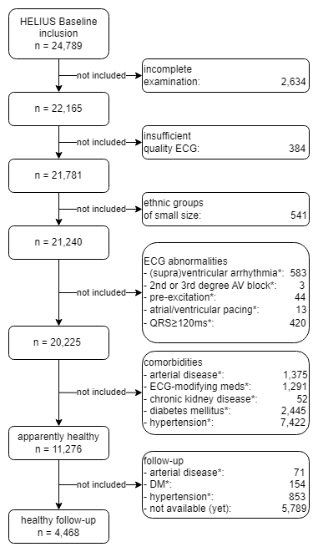

*Figure 2. Percentile curves from the GAMLSS models for QRS complex duration (in ms) for males of all the six ethnicities of the apparently healthy population. The upper line is the 97.5th percentile, the middle one is the mean and the lower line in the 2.5th percentile, predicted using the GAMLSS model. Highlighted in orange is the current area that fits the normal limits according to AHA/ACCF/HRS* *guidelines.*

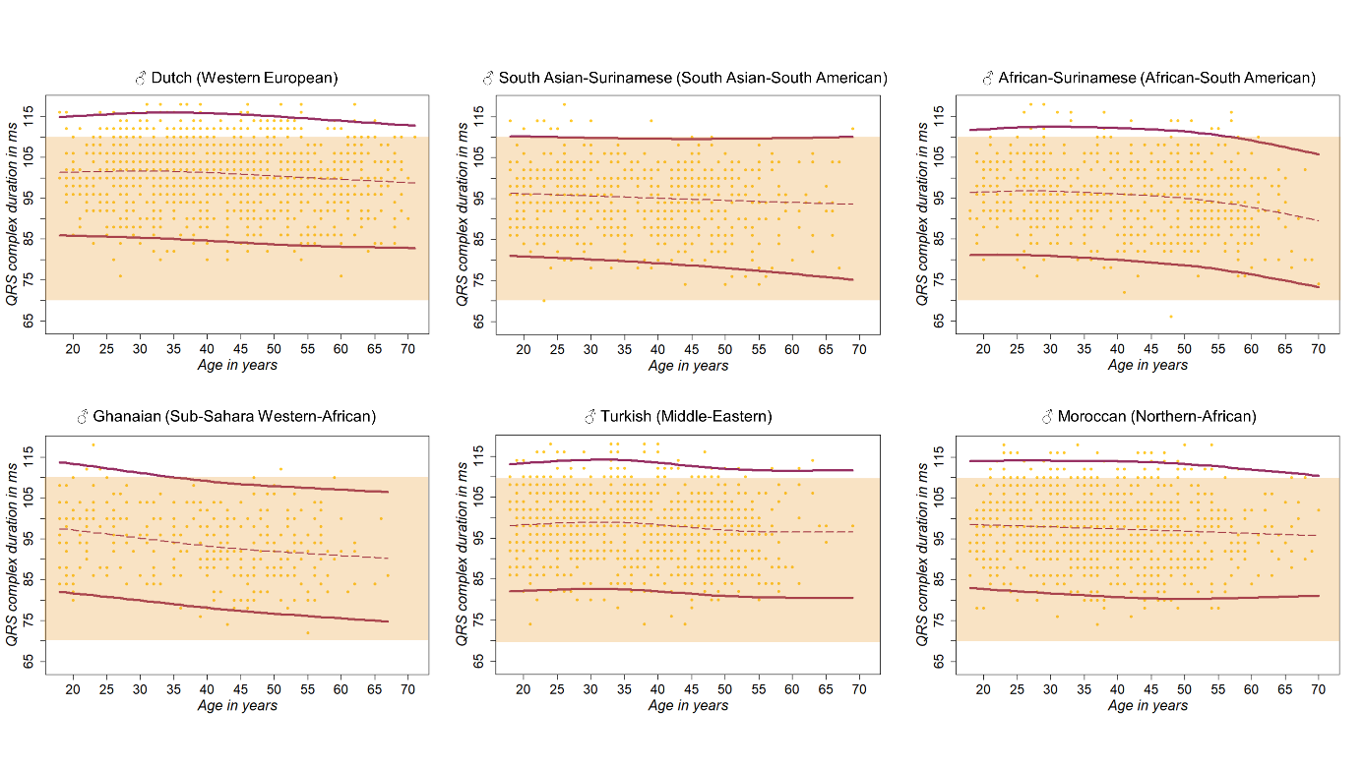

*Figure 3. Percentile curves from the GAMLSS models for QRS complex duration (in ms) for females of all of the six ethnicities of the apparently healthy population. The upper line is the 97.5th percentile, the middle one is the mean and the lower line in the 2.5th percentile, predicted using the GAMLSS model. Highlighted orange is the current area that fits the normal limits according to AHA/ACCF/HRS guidelines.*